*Project Report*

*On*

*HomeService:*

*WUW- WhatUWant*



**Submitted By: Submitted To:**

**Asiah Farooq Khalidi Dr. Mohammad Haroon**

ROLL NO.:1801012031 (Project Supervisor)

**Anam Fatima**

ROLL NO.:1801012021

**Mariyam Zehra**

ROLL NO.:1801012061

**COURSE/DEPARTMENT/GROUP:**

B.TECH/CSE/GROUP-1

**SEMESTER/YEAR:**

8TH SEMESTER/4TH YEAR

**INTEGRAL UNIVERSITY, LUCKNOW**

**YEAR:**

2021-2022

**STATEMENT OF ORIGINALITY**

**UNDERTAKING**

We, Asiah Farooq Khalidi, Anam Fatima and Mariyam Zehra, students of B.Tech (Computer Science and Engineering, Group-1), hereby declare that the work detailed in this Project- “HomeService: WUW-WhatUWant” submitted to Computer Science and Engineering Department is all our own work. We have not copied our work from any resources to which we had access. Any work taken from another source has been appropriately referenced and acknowledged.

**DATE:**  March 16th, 2022

**NAME:**

ASIAH FAROOQ KHALIDI (ROLL NO.: 1801012031)

ANAM FATIMA (ROLL NO.: 1801012021)

MARIYAM ZEHRA (ROLL NO.: 1801012061)

**CERTIFICATE**

This is to certify that the work detailed in this Project Report on “HomeService: WUW-WhatUWant” by Asiah Farooq Khalidi, Anam Fatima and Mariyam Zehra, students of B.Tech (Computer Science and Engineering, Group-1), is a faithful record of work that has been carried out by the students under my supervision. To the best of my knowledge, this work is entirely the team’s own work.

**DATE:** March 16th, 2022

**NAME OF SUPERVISOR:**

Dr. Mohammad Haroon

**SIGNATURE OF SUPERVISOR:**

……………………………………

**RECOMMENDATION**

On the basis of the declaration submitted by Asiah Farooq Khalidi, Anam Fatima and Mariyam Zehra, internal assessment carried out by the department on date 16/03/2022 and the certificate issued by the Project Supervisor- Dr. Mohammad Haroon, the project- “HomeService: WUW-WhatUWant” submitted to the department of Computer Science and Engineering, is recommended for final examination.

|  |  |
| --- | --- |
| ………………………… | ………………………….. |
| (Signature of B.Tech Project Coordinator) | (Signature of HOD) |
| **MR. IJTABA SALEEM KHAN** | **DR. M. AKHEELA KHANNUM** |
| (Assistant Professor) | (Head of Department) |
| Department of Computer Science & Engineering | Department of Computer Science & Engineering |

DATE: March 16th 2022

**ACKNOWLEDGEMENT**

Thanking everybody is such a crucial task. And without performing that, any good work remains incomplete.

Every constructive work needs some fuel as its driving force. The fuel in our case was every little stone of help and appreciation that we received from our Project Supervisor- Dr. Mohammad Haroon, our team mates and our parents all through the way while completing this skillful project on “HomeService: WUW-WhatUWant”

Thanking You

**ASIAH FAROOQ KHALIDI**

ROLL NO.: 1801012031

**ANAM FATIMA**

ROLL NO.: 1801012021

**MARIYAM ZEHRA**

ROLL NO.:1801012061

**Project Report Outline:**

* About Project
* Requirements
* Technology Used
* Project Progress Plan Including 7 phases of software development
* Role of members individually

**About project:**

In present scenario, people are buried up in a heavy work culture, as everyone is engaged with busy schedules, and hectic tasks which make them deviate from family life. If any issues encounter unexpectedly, it distracts them and makes them choose over the work they have to accomplish primarily. It is important to manage both professional and family life.

In such circumstances, every one of us would have fantasized about a kind of house which doesn’t have any leaks in pipes, if it doesn’t have any mess in fixing a furniture and a kind of house which never face any maintenance issues and every one of us have thought that a life would be much better if no point of issue arises in getting a service at your door step and if there is no mess in bargaining a labor for home service.

In such situation’s E-Commerce plays a vital role in today’s life as it has so many advantages in our life because it makes convenient in daily life of the people. So, giving a thought to that aspect of life is to design and develop a system that provides many services at your doorstep in just one click. A System that provides variety of services like plumbers, repair persons, cleaners, electricians, painters, taxi service laundry and many more. To make it comfortable for all the users our system also provides a mobile environment which offers ease in accessing our services that is Booking Home and Individual Services.

Booking Home and Individual Services is online platform that provide Customers to hire trained workers online for their home services. Its aim is to provide quick and best quality services to their customers.

**Requirements:**

* Hardware and Software Requirements
  + Hardware Specification
    - Android Device
    - 8GB RAM
  + Software Specification
    - Android Studio
    - Firebase
    - Android virtual Machine

**Technology Used:**

* Front End
  + XML
* Back End
  + Firebase
  + Java

***XML:***

* XML stands for Extensible Markup Language.
* XML is Extensible.
* XML focuses on data rather than how it looks.
* XML is a public standard.

***Firebase:***

* Used for mobile app development and web development.
* Stores data and also works as a server.
* The main goal of the system is to provide a secure, reliable and fast way to synchronize data with a minimal amount of coding effort on the part of the developer.
* The purpose of the Realtime Database feature of Firebase is to allow data to be shared between multiple clients.

***JAVA:***

* Java is platform-independent.
* It is used for developing Android Apps.
* It is a computing platform for application development
* It is fast, secure, and reliable.
* Java Platform is a collection of programs that help programmers to develop and run Java programming applications efficiently.

**Project Progress Plan:**

* First three phases of software development i.e.:
  + Planning
  + Requirement Analysis
  + Design

has been completed till now.

* Next phases which are yet to be completed are:
  + Development
  + Testing
  + Implementation
  + Maintenance

***Design Phase:***

***Level 0 DFD:***

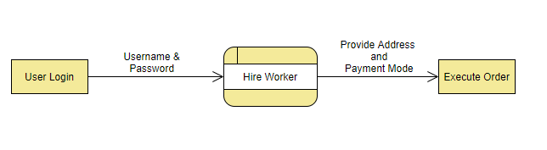

***Level 1 DFD:***

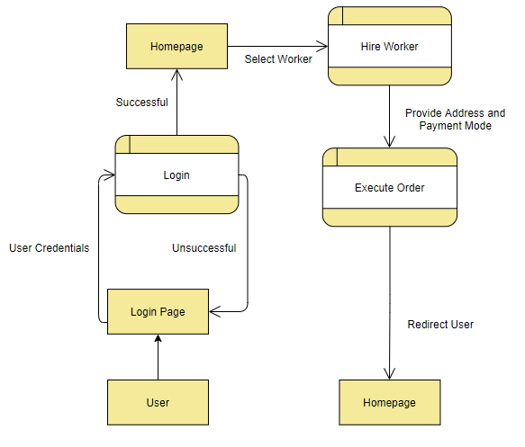

***ER Diagram:***

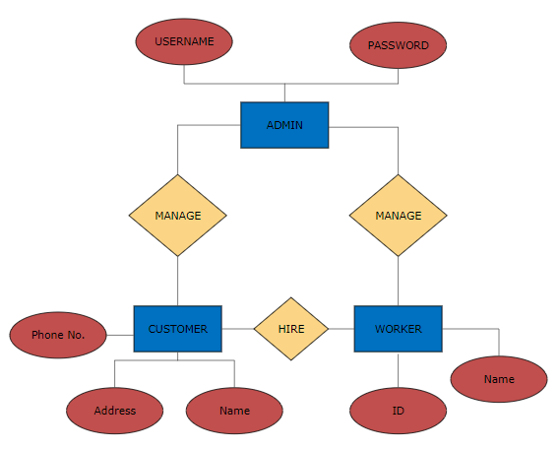

**Role Of Members Individually:**

* Planning: Mariyam Zehra
* Requirement Analysis: Anam Fatima
* Design Analysis: Asiah Farooq Khalidi

We have done each and every work in coordination.

We have helped each other in every way.